**ECEN 214 - 302**

**Lab member: Alex Allahar**

**TA: Navid Naseh**

**Date lab performed: 07/07/22**

**Date report is due: 07/10/22**

1. **Procedure**

**Task 1**

The first part of this lab is to create an emitter circuit. After placing the emitter and a resistor(RE) on a breadboard connect 5V from the AD2. Measure the voltage across the emitter and across the resistor. After recording these values the current across the emitter can be calculated. Repeat this process with different Re values between 100 and 1000 ohms.

Next, create a detector circuit that is similar to the emitter circuit. Once this circuit has been constructed connect 5V from the AD2, and place around 1 cm away from the emitter. Measure and record the detector voltage. Repeat this process with different resistor(RD) values from 100-1000 while keeping the RE the same value. Record the RD values to later calculate the current across the dectector.

Finally, create the Op-Amp detector circuit shown in the lab manual. Compare the VD from this circuit to the VD from the detector circuit at the same distance from the emitter and same resistor values. After comparing the two values, measure the voltage while the op-amp detector and emitter are obstructed. Next measure the max distance between the op-amp detector and emitter while the omp-ap detector can still provide a voltage.

**Task 2**

Create the inverting signal voltage amplifier circuit shown in the lab manual. Use a 100 kilo ohms resistor for R1 and a 360 kilo ohms resistor for R2. This combination should prevent saturation for Vin values between 0 and 1. Measure Vout values for different Vin inputs between 0 and 1. Recorded these measurements.

The next circuit is the non-inverter. To create this circuit use a 2 kilo ohms resistor for R1, a 5.1 kilo ohms resistor for R2, and a 1 kilo ohm resistor for a R3. Similarly, the inverter measures the Vout values for different Vin inputs between 0 and 1. Recorded these measurements.

**Task 3**

For the final circuit create a voltage comparator. Picking 2 V for Vr, use Vi(input) values from 1.9 to 2.1 V. Measure and record the output voltage as Vo values.

1. **Data tables with results**

| **Emitter** |  |  |  |
| --- | --- | --- | --- |
| RE (Ohms) | V_RE (V) | V_IE (V) | IE (A) |
| 100 | 3.564 | 1.427 | 0.01427 |
| 200 | 3.654 | 1.345 | 0.006725 |
| 500 | 3.729 | 1.271 | 0.002542 |
| 600 | 3.738 | 1.26 | 0.0021 |
| 1000 | 3.766 | 1.233 | 0.001233 |

**Figure 1: Task 1 Emitter Data**

| **Dectector** |  |  |
| --- | --- | --- |
| RD (Ohms) | V_D (V) | ID (A) |
| 100 | 0.415 | 0.00415 |
| 200 | 0.791 | 0.003955 |
| 500 | 1.387 | 0.002774 |
| 600 | 1.799 | 0.002998333333 |
| 1000 | 2.25 | 0.00225 |

**Figure 2: Task 1 Detector Data**

| **Inverting** | R1=100kohms | R2=360kohms |
| --- | --- | --- |
| Vin (V) | Vout (V) |  |
| 0.0001 | 0.003 |  |
| 0.1 | -0.338 |  |
| 0.2 | -0.701 |  |
| 0.3 | -1.063 |  |
| 0.4 | -1.429 |  |
| 0.5 | -1.79 |  |
| 0.6 | -2.157 |  |
| 0.7 | -2.517 |  |
| 0.8 | -2.884 |  |
| 0.9 | -3.077 |  |
| 1 | -3.107 |  |

**Figure 3: Task 2 Invertering Data**

| **Non-Inverting** | R1=2kohms | R2=5.1kohms |
| --- | --- | --- |
| Vin (V) | Vout (V) | R3=1kohms |
| 0.0001 | 0.002 |  |
| 0.1 | 0.359 |  |
| 0.2 | 0.72 |  |
| 0.3 | 1.079 |  |
| 0.4 | 1.441 |  |
| 0.5 | 1.798 |  |
| 0.6 | 2.161 |  |
| 0.7 | 2.518 |  |
| 0.8 | 2.881 |  |
| 0.9 | 3.235 |  |
| 1 | 3.596 |  |

**Figure 4: Task 2 Non-Inverter Data**

| **Comparator** | R1=3.3kohms | R2=2.2kohms |
| --- | --- | --- |
| Vin (V) | Vout (V) | VR=2V |
| 1.9 | 0.007 |  |
| 1.925 | 0.006 |  |
| 1.95 | 0.007 |  |
| 0.1975 | 0.007 |  |
| 1.99 | 0.007 |  |
| 1.999 | 4.561 |  |
| 2 | 4.561 |  |
| 2.025 | 4.561 |  |
| 2.05 | 4.561 |  |
| 2.075 | 4.561 |  |
| 2.1 | 4.561 |  |

**Figure 5: Task 3 Comparator Data**

1. **Sample calculations**

$V_{out}= \frac{-R_{2}}{R_{1}}V_{in}$**Equation 1**

Equation for amplification of inverting amplifier

$V_{out}= \frac{R_{1}+R_{2}}{R_{1}}V_{in}$**Equation 2**

Equation for amplification of non inverting amplifier

1. **Tasks**

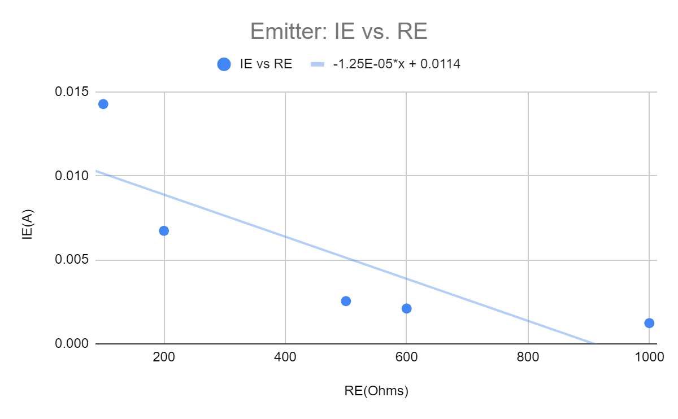

**Figure 6: Emitter IE vs RE plot**

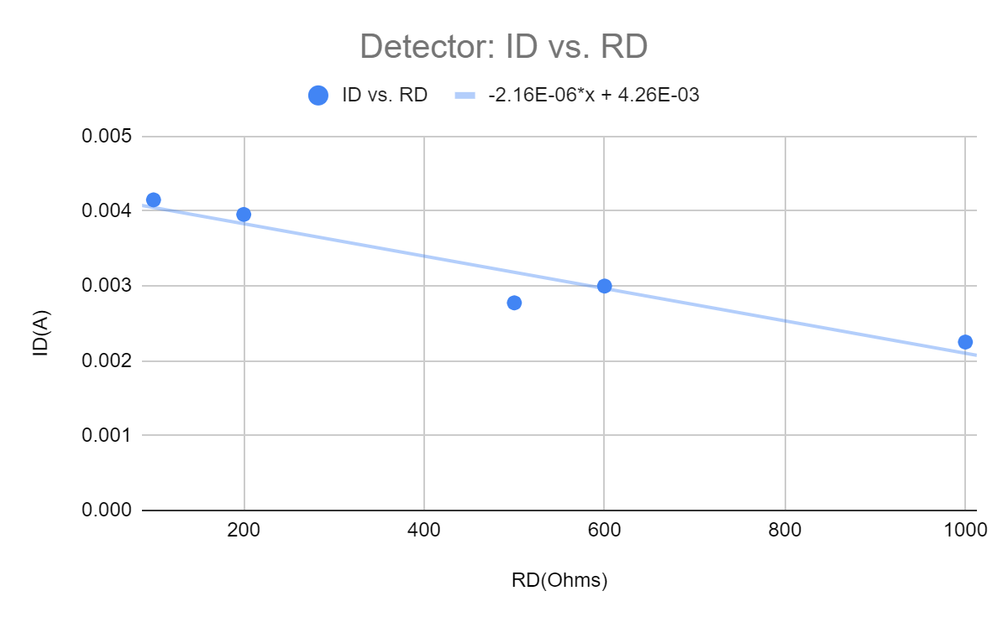

**Figure 7: Detector ID vs RD plot**

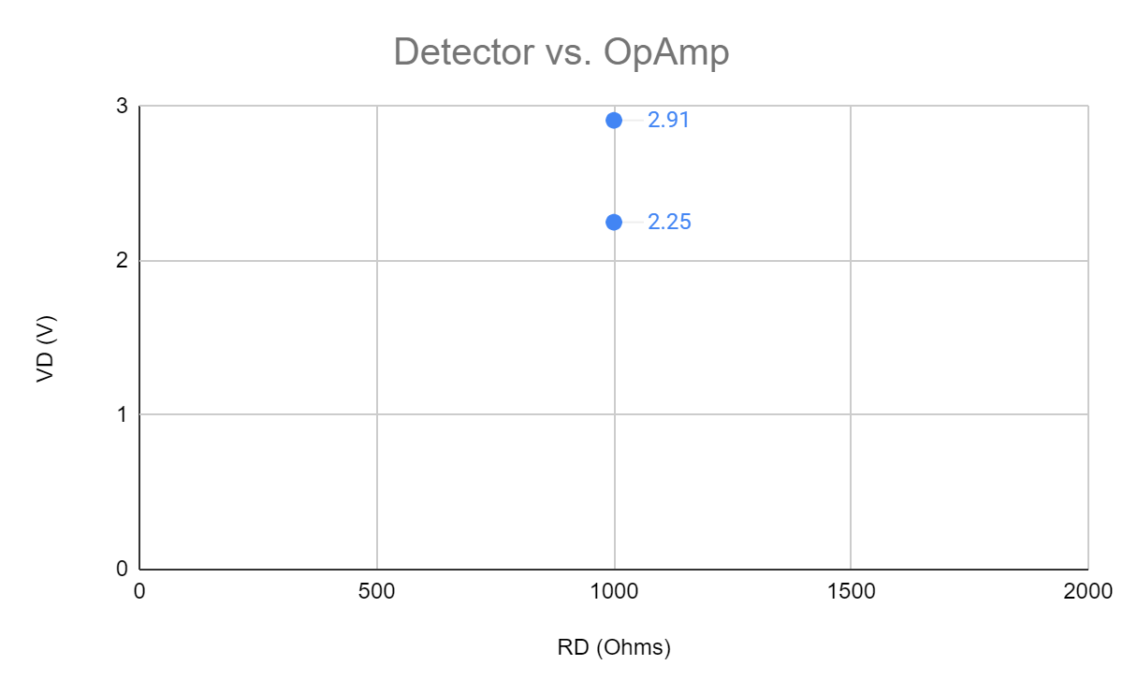

**Figure 8: Detector vs Amp Op plot**

**What resistor values did you finally decide upon and why?**

I decided to set the RE to 100 Ohms and the RD to 1,000 Ohms. The 100 Ohms for the emitter is the minimum value of resistor I can use for the emitter. The 1,000 Ohms for RD allows the maximum amount of current to flow through the resistor, which will create the highest voltage possible.

**How far apart were you able to place the emitter and detector and still have the circuit function as intended?**

It was determined that at a distance of 30 cm, the voltage would be 0.263 Volts. There was still a measurable voltage difference when the detector was obstructed or unobstructed, so the circuit could still be able to function as intended at this distance.

**What were the detector voltages that you measured for the obstructed and unobstructed cases (with the pair placed as far apart as you could)?**

With the pair placed 30 centimeters apart, the voltage was 0.263 V unobstructed or 0.01 V obstructed.

**Explain how the op-amp circuit of figure 4.11 is better or worse than the simple resistor used previously.**

The op-amp detector circuit is better than the simple detector resistor circuit, as it caused a slightly larger voltage (2.91 V) when the distance (1 cm) and resistance values (each 1000 Ohms) were held constant. This is because the detector has a small internal resistance, so when in the operational amplifier circuit the small resistance causes a larger output voltage than the simple resistor circuit.

**Task 2**

**Be sure to indicate what your saturation voltages are.** 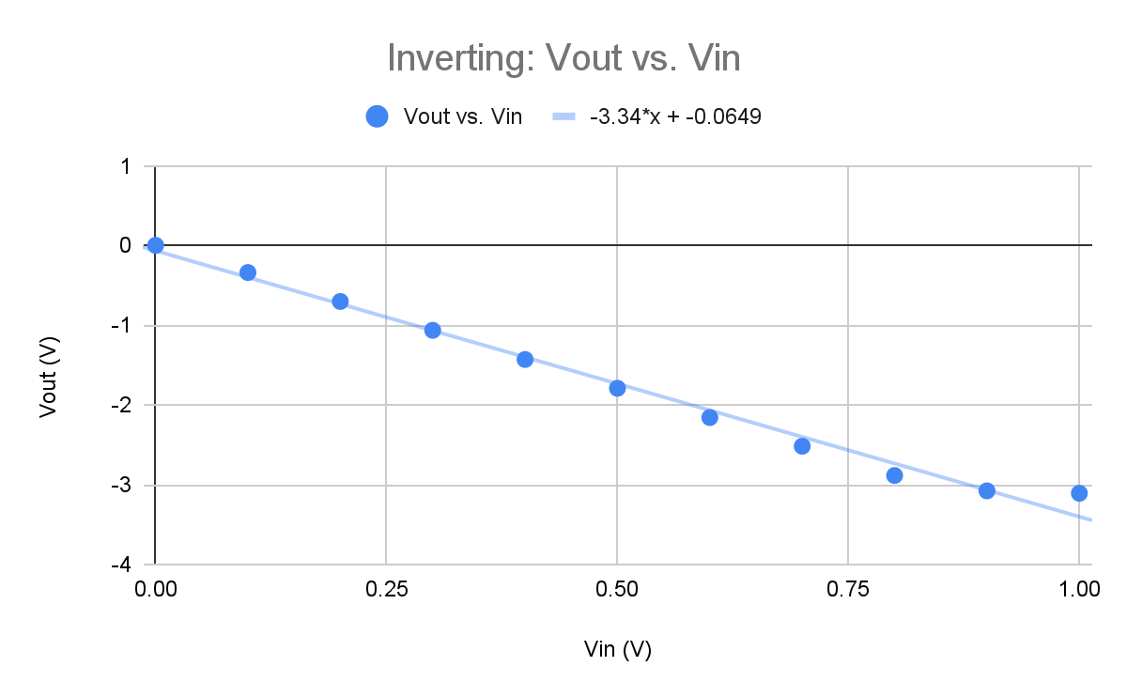

**Figure 9: Inverting Vout vs. Vin plot(**The saturation voltage is -3.107 V.)

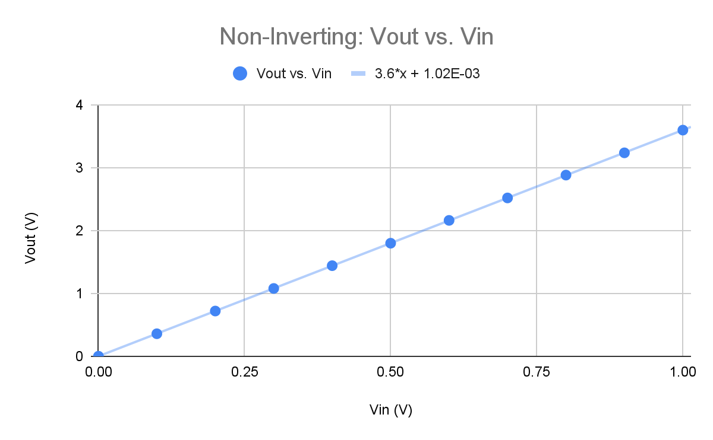

**Figure 10: Non-Inverting Vout vs. Vin plot**(The saturation voltage is 3.596 V.)

**Comment on which amplifier circuit would couple better with the detector circuit(s) of**

**Task 1? Why?**

The Non-Inverting amplifier circuit would couple better with the detector circuit of task 1. The Non-Inverting amplifier does not invert the value, and it has a higher saturation voltage. A higher saturation voltage allows a higher reference voltage for the comparator.

**Task 3**

**Discuss what resistance values you chose and why.**

R1 was chosen to be 3.3 kiloohms and R2 was chosen to be 2.2 kiloohms, so the reference voltage could be 2 V. This reference voltage was chosen because the inverting amplifier became saturated around -3.107 volts and the non-inverting amplifier became saturated around 3.596 V. 2 V is a value that is relatively in the middle of the linear range for either amplifier.

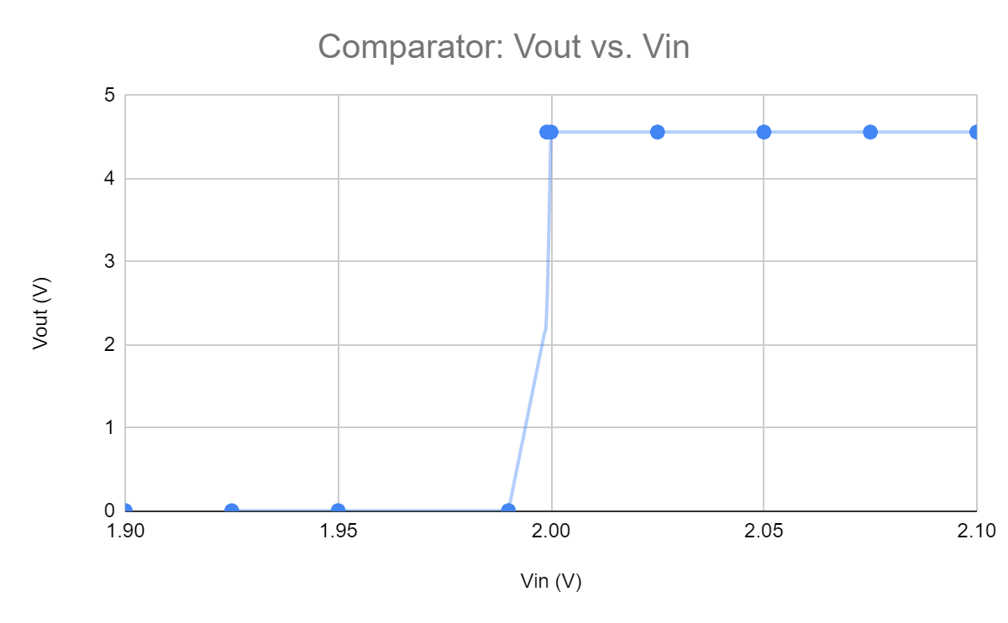

**Figure 11: Comparator Vout vs. Vin plot**

**Discuss what the input voltages need to be to cause the output to produce each of the desired logic levels.**

A low output logic level was produced when the input voltage was 1.99 V or below. A high output logic level was produced when the input voltage was 1.999 V or above. There was an “in between” output voltage when the input voltage was between 1.99 volts and 1.999 V.